JOUR 4251
Psychology of Advertising 4.2 Attitudes
Recap Tuesday
● Baddeley & Hitch Model of working (short-term) memory ○ Central executive

○ Phonological loop
○ Visuospatial sketchpad
○ Episodic buffer
● Long term memory
○ Explicit memory
■ Semantic vs. episodic
○ Implicit memory
○ Priming
■ supraliminal vs. subliminal
○ Knowledge structures
■ Categories, scripts, networks (nodes & links) ● Forgetting the message
What is an attitude?
1. Evaluative responses
“Attitude is a psychological tendency that is expressed by evaluating a particular entity with some degree of favour or disfavour” (Eagly and Chaiken, 1993)
What is an attitude?

2. Directed to an attitude object

What ia an attitude?
3. Derived from 3 classes of information:
1. Cognitive
○ Based on information
2. Affective
○ Based on feelings. emotions, mood 3. Behavioral
○ Based on behavior
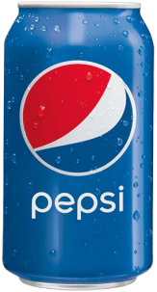
Self-perception theory We infer our attitudes from our own behavior.
How often do you drink Pepsi?
- Frequent? You must like it!
- Never? You must not like it.
What do you think?
Attitudes are a(n)?
1. Predisposition to evaluate 2. Evaluative response in itself
Attitudes are…?
1. Stable over time
2. Context dependent
Explicit versus implicit attitudes
Explicit attitudes
● Evaluations of which the individual is consciously aware Implicit attitudes
● Individual is not aware they have these attitudes. ● They influence reactions over which the individual has no control.
Measuring attitudes
To what extent do you believe brand X is...
Positive 0 0 0 0 0 0 0 Negative
Good 0 0 0 0 0 0 0 Bad
Interesting 0 0 0 0 0 0 0 Not interesting
Valuable 0 0 0 0 0 0 0 Not valuable
Measuring attitudes Affect misattribution procedure (AMP)

75 ms
125 ms
100 ms
Instructions:
- Flashing pictures, first one being a real-life image, second Chinese character
- Real-life image simply serves as a warning signal
- Judge visual pleasantness of Chinese character
- Two keys (pleasant vs. unpleasant) - As quickly as possible
Measuring attitudes
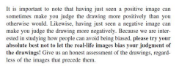
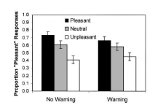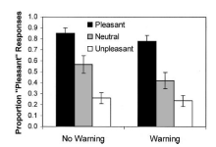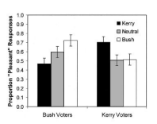
Warning:
Sometimes, the photographs presented prior
to the Chinese characters can bias your
responses on those characters. Thus,
please try to make sure that your responses
are not influenced by the photographs.
*Payne, B. K., Cheng, C. M., Govorun, O., & Stewart. B. D. (2005). An Inkblot for attitudes: affect misattribution as implicit measurement. Journal of Personality and Social Psychology, 3, 277-293.
Implicit-association test (IAT)
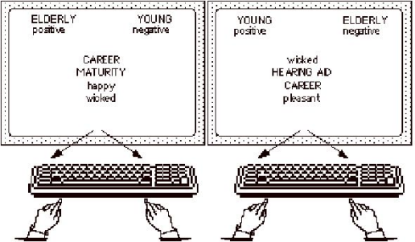
Implicit-association test (IAT)
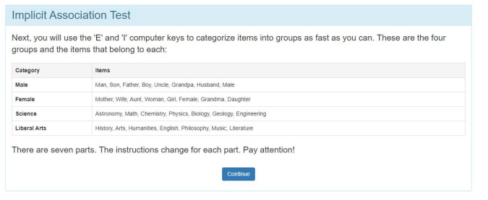
Implicit-association test (IAT)
Implicit-association test (IAT)
Explicit vs. implicit measures
Which one should you use?
Conscious process Nonconscious process
Explicit measure A B Implicit measure C D
Video
Think about the following three questions:
1) How might this research be relevant to advertisers?
2) Why might advertisers be interested in implicit attitudes more generally?
3) What other kinds of implicit attitudes might advertisers be interested in testing?
Video
Think about the following three questions
1) How might this research be relevant to advertisers?
2) Why might advertisers be interested in implicit attitudes more generally?
3) What other kinds of implicit attitudes might advertisers be interested in testing?
Take the test yourself
Link is included in the
notes of the slides.
Explicit vs. implicit measures
Be careful in interpreting results. Two problems:
1) You may find something that isn’t really there
2) You may ignore existing results
What do the results tell us?
No explicit effect Explicit effect
No implicit effect I II Implicit effect III IV
What’s next?
● Continue reading Chapter 4 (attitudes)
○ Submit reading response by Feb 20 before class starts
● Exam 1 will be on February 27
○ In class, bring your own laptop (unless you told us)
● We will have a review session on February 25 (Tuesday)
○ Submit review question by Feb 20 (12.5 points for participation/engagement) ■ Submit a question on content! What needs additional clarification. ● NOT: do we need to know the brands of the ads shown in class?
● NOT: do we need to know specific experiments?
● I will go over that in the review session anyway (the answer is no).

